[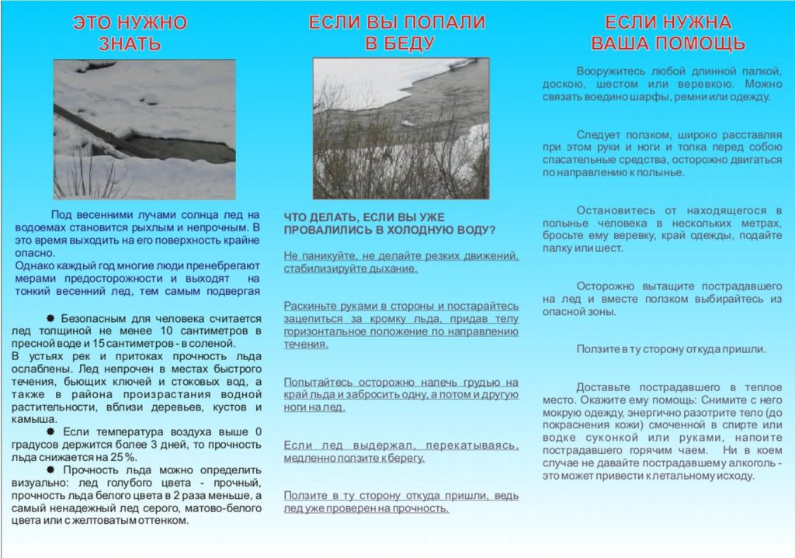](http://umcamur.ru/wp-content/uploads/%D0%9D%D0%B0-%D0%BB%D1%8C%D0%B4%D1%83.jpg)